Ideation Phase
Define the Problem Statements

Date | 15 June 2026
Team ID | Pulkit Khera
Project Name | OnlineComplaintRegistration
Maximum Marks | 2 Marks

Customer Problem Statement Template:
[Create a problem statement to understand your customer's point of view. The Customer Problem Statement template helps you focus on what matters to create experiences people will love.
A well-articulated customer problem statement allows you and your team to find the ideal solution for the challenges your customers face. Throughout the process, you’ll also be able to empathize with your customers, which helps you better understand how they perceive your product or service.]
Reference: https://miro.com/templates/customer-problem-statement/
Example:
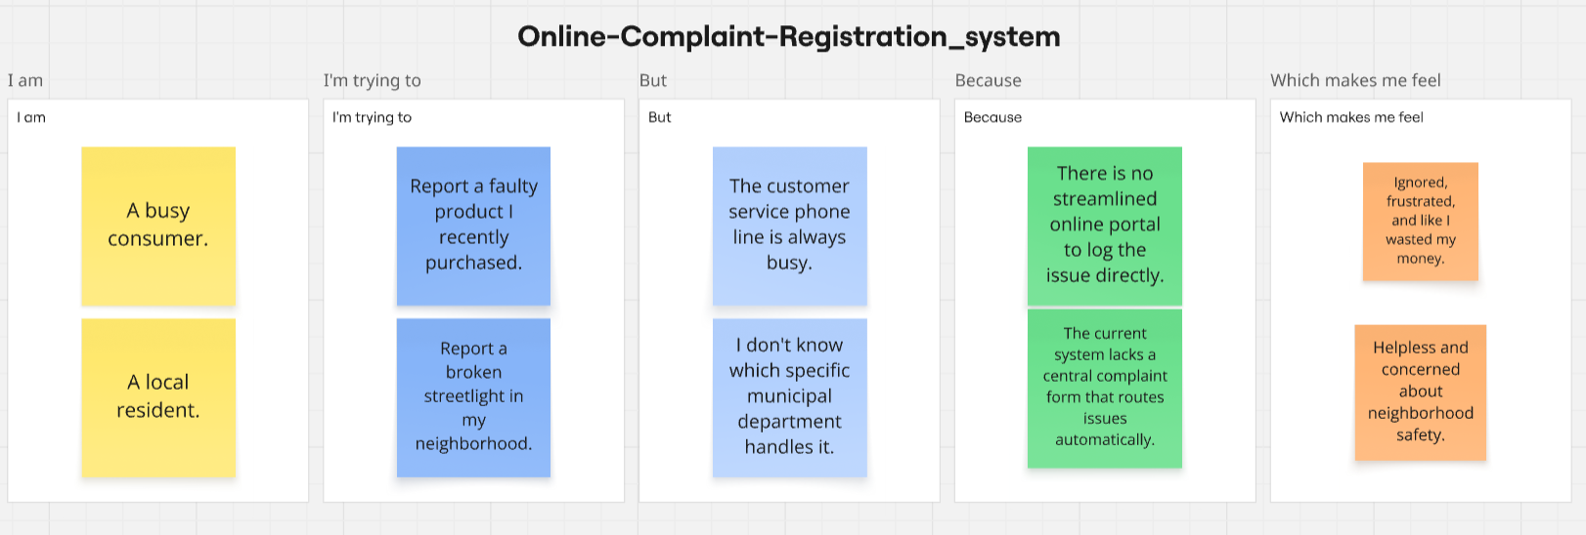

Problem Statement (PS) | I am (Customer) | I’m trying to | But | Because | Which makes me feel
PS-1 | A busy consumer. | Report a faulty product I recently purchased. | The customer service phone line is always busy. | There is no streamlined online portal to log the issue directly. | Ignored, frustrated, and like I wasted my money.
PS-2 | A local resident. | Report a broken streetlight in my neighborhood. | I don't know which specific municipal department handles it. | The current system lacks a central complaint form that routes issues automatically. | Helpless and concerned about neighborhood safety.

